**The Battle of Long Island**

**RULES:** Practical Shooting Handbook, Latest Edition **COURSE DESIGNER:** Ike Starnes

|  |  |
| --- | --- |
| **START POSITION: See written stage briefings.** | |
| **STAGE PROCEDURE**  Engage targets from within the shooting area. | **SCORING**  **SCORING:** Comstock 22 rounds.  **TARGETS:** 11 cardboard targets  **SCORED HITS:** 2 Best hits per carboard will be scored  **START-STOP:**  Audible - Last shot  **PENALTIES:** Mike -10, NS -10, Procedural -10 |

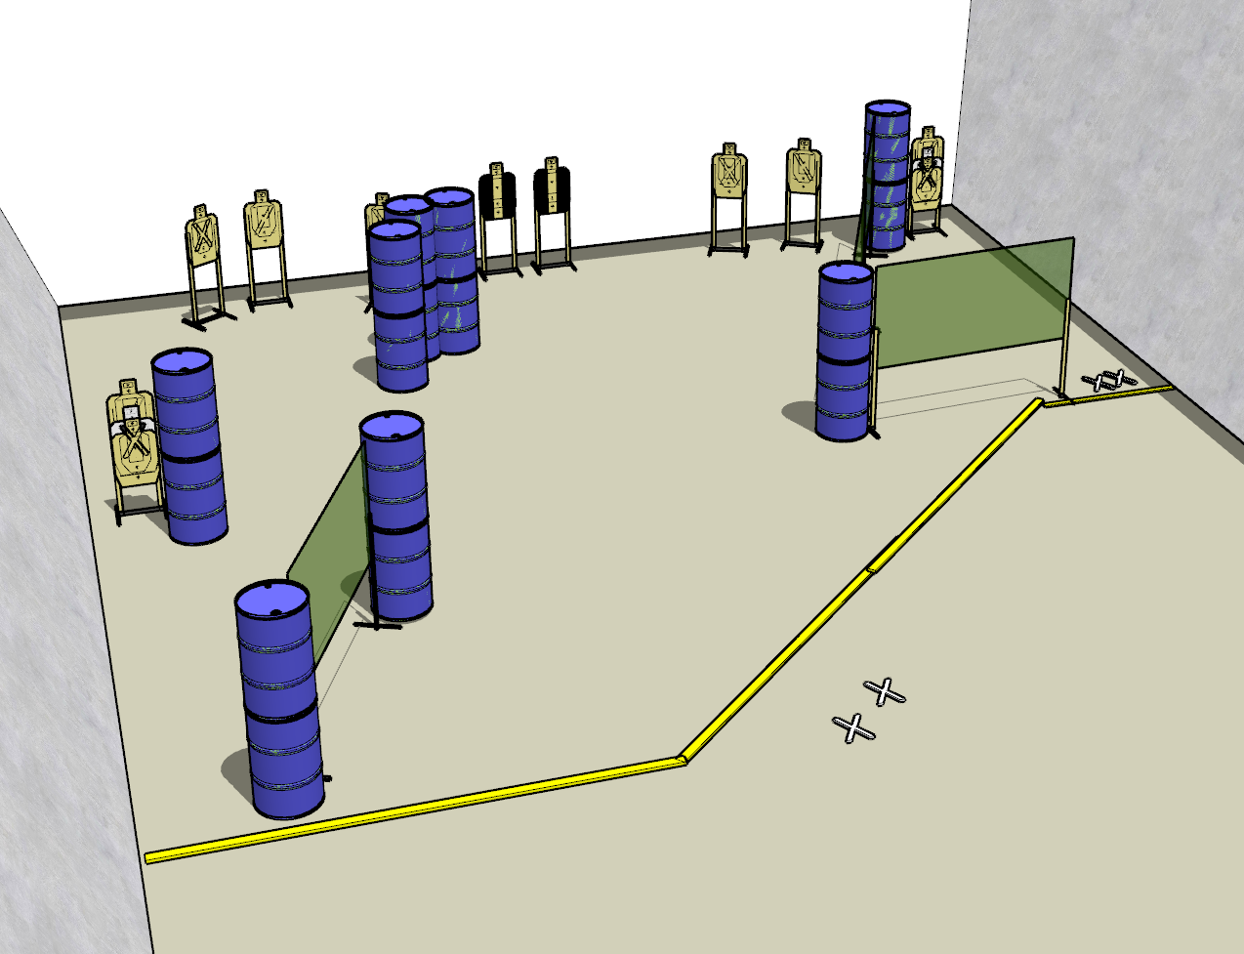

**Written Stage Briefings:**

**Stage 1 –** is a 22-round, 110 point, Comstock Long Course. There are 11 cardboard targets. The best 2 hits per cardboard target will be scored.

**Handgun start position** is both hands touching marks on barrel. The handgun is **loaded** and holstered.

**PCC start position** is muzzle touching mark on barrel. PCC is **loaded**.

On the audible start signal, engage targets from within the shooting area. The last two targets must be engaged strong hand/shoulder only.

**Stage 2 –** is a 22-round, 110 point, Comstock Long Course. There are 11 cardboard targets. The best 2 hits per cardboard target will be scored.

**Handgun start position** is both feet on center Xs. The handgun is **unloaded** and holstered.

**PCC start position** is both feet on center Xs. PCC is **unloaded**, held in both hands, muzzle pointed downrange.

On the audible start signal, engage targets from within the shooting area.

**Stage 3 –** is a 22-round, 110 point, Comstock Long Course. There are 11 cardboard targets. The best 2 hits per cardboard target will be scored.

**Handgun start position** is both feet on right side Xs. The handgun is **loaded** and holstered.

**PCC start position** is both feet on right side Xs. PCC is **loaded**, held in both hands, with muzzle pointed downrange.

On the audible start signal, engage targets from within the shooting area. The last two targets must be engaged weak hand/shoulder only.